DESIGN TABLES FOR PRODUCT AND CATEGORY ENTITIES.
Project Title: E-Commerce Order Management Database System

Project Title : E-Commerce Order Management Database System
Student Name : Asan Ahamed H
Register Number : C4S38006
Department : Bsc.AI
Course : Artificial intelligence (AI)
Academic Year : 2026 – 2027

DBMS Practical - Product and Category Module
E-Commerce Order Management Database System

Design Tables
CREATE DATABASE E-Commerce_Order
CREATE TABLE Category(
CategoryID INT PRIMARY KEY,
CategoryName VARCHAR(100),
Description VARCHAR(255));
CREATE TABLE Product(
ProductID INT PRIMARY KEY,
ProductName VARCHAR(100),
CategoryID INT,
Price DECIMAL(10,2),
Stock INT,
FOREIGN KEY(CategoryID) REFERENCES Category(CategoryID));
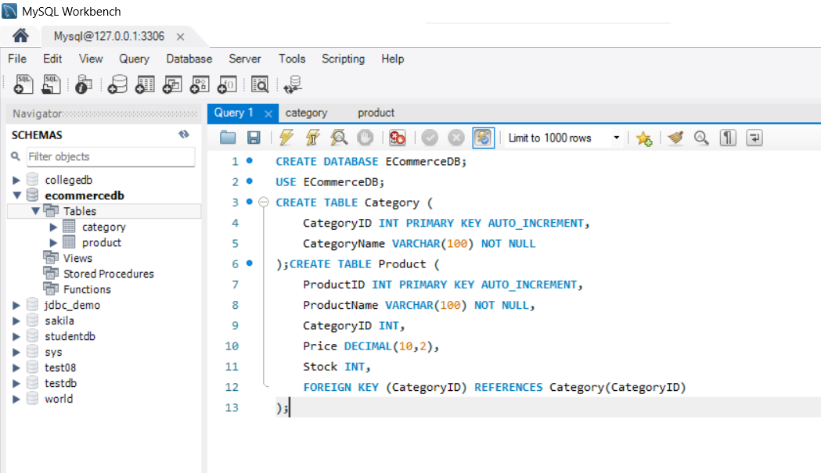

2. Primary and Foreign Keys
Primary Key
- Category → CategoryID
- Product → ProductID
Foreign Key
- Product.CategoryID
- References Category(CategoryID

3. Insert Records
INSERT INTO Category (CategoryName)
VALUES
('Electronics'),
('Fashion'),
('Books'),
('Home Appliances');
INSERT INTO Product (ProductName, CategoryID, Price, Stock)
VALUES
('Laptop',1,65000,15),
('Smartphone',1,25000,30),
('T-Shirt',2,799,50),
('Novel',3,450,20),
('Microwave Oven',4,9000,10);

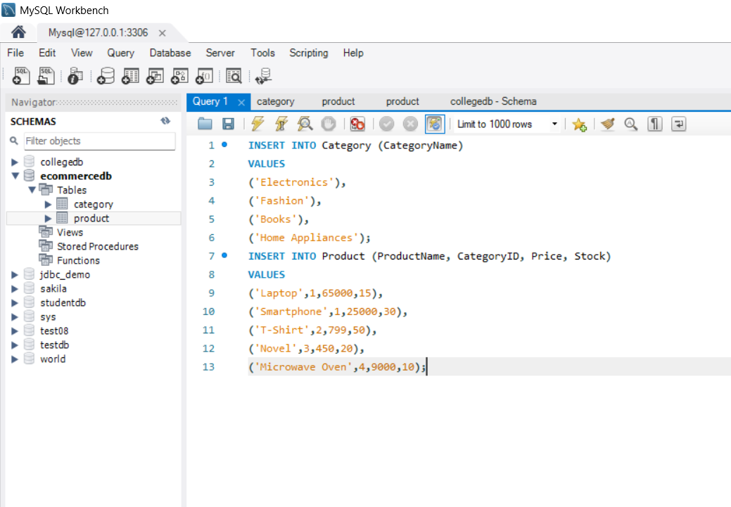

4. Insert, Update and Delete
INSERT INTO Product
VALUES (106, 'Headphones', 1, 2500.00, 40);

UPDATE Product
SET Price = 2300.00,
Stock = 45
WHERE ProductID = 106;

DELETE FROM Product
WHERE ProductID = 106;
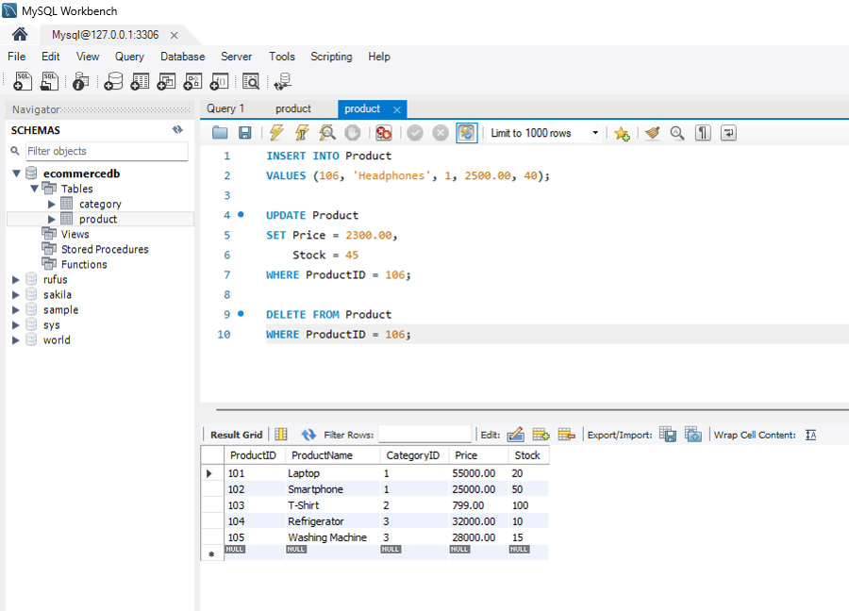

5. Category-wise Reports
SELECT
C.CategoryName,
P.ProductID,
P.ProductName,
P.Price,
P.Stock
FROM Product P
JOIN Category C
ON P.CategoryID = C.CategoryID
ORDER BY C.CategoryName;
